FINAL PROJECT
Asset Management System

Management Information System (MIS) Section
PT. Sharp Semiconductor Indonesia
2017

- Introducing

- Project Name
Project to control this asset is called the Asset Management System, where the system is able to store all the data assets at PT Sharp Semiconductor Indonesia, asset report printing, print asset number and other processes associated with asset transactions.

- Team & Project Manager
The Manager of this Project is Mr. E. Setiawan as MIS Section Head and this project has been completed by Husni Mubarok as MIS staff PT Sharp Semiconductor Indonesia.

- Scope

- Operation & Implementation Restriction
Asset Management system is only used in PT Sharp Semiconductor Indonesia and several Section-related who need this system.

- User
The users are divided into 4 access group:
- Superadmin
The user can access all functions and menus on the system.
- Administrator
The user has the task of controlling the asset according to section.
- Requesting transfer of assets.
- Requesting disposal of asset.
- View, edit and delete asset.
- Approval
Users can approve some transactions asset.
- Approved the transfer of assets.
- Approved the disposal of asset.
- View asset list.
- Accounting
Users in section accounting that can perform some special functions.
- Registration Asset.
- Approved the transfer of asset.
- Approved the disposal of asset.
- View, edit, and delete asset.
- Print out check sheet for stocktaking.
- Print out report asset.

- Project Development
In the development of Asset Management System uses several tools, namely:
- IIS Server.
- PHP 5.
- MYSQL.
- SQL Server 2008.
- Code Igniter.
- Bootstrap and jquery.

- Implementation
Asset Management System implementation will be started at 4th week of February 2017.

- System and Infrastruktur
- Network
Asset Management System use online web based system that work in client-server platform.
In this project, MIS Section provide a PC Server in MIS Room, while client PC is provided in every section.

- Hardware
Recommended hardware specification:
- Server
    - Processor : intel R(xeon) 3.00 Ghz
    - Memory : 2 GB
    - Harddisk : 110 GB
- Client
    - Processor : Pentium IV
    - Memory : 1GB
    - Harddisk : 20 GB
- Software
Recommended Software specification:
a. Server
- Operating System : Windows Server 2003 SP1
- Database System : MYSQL 4.1.14
b. Client
- Operating System : Windows XP SP3
- Browser : Google Chrome and IE 11
- System Development Methods
- Analysis

- Business Flow

- Process Flow
- Activity Diagram

- Use Case Diagram

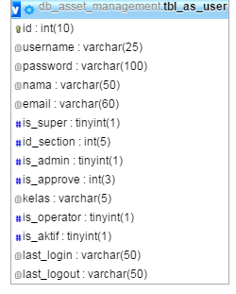
- Database
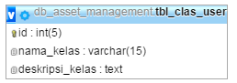

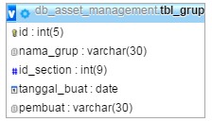

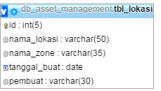

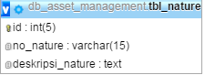

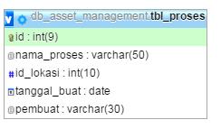
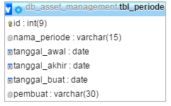

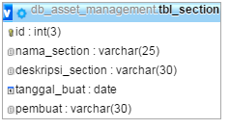
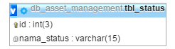

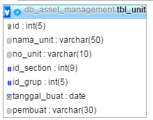

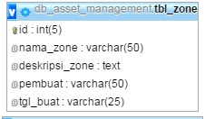

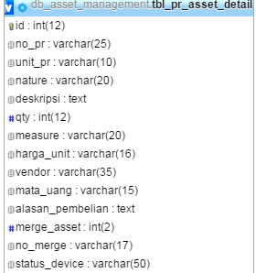
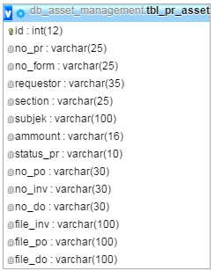

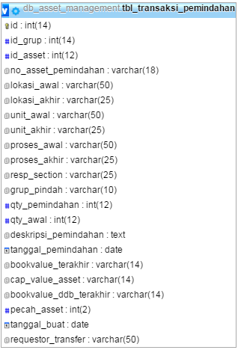
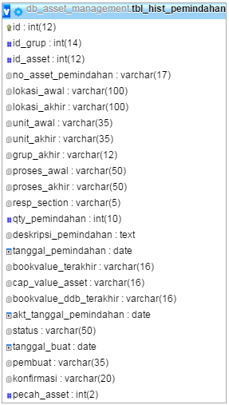

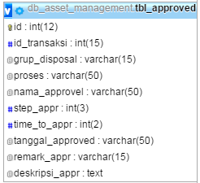
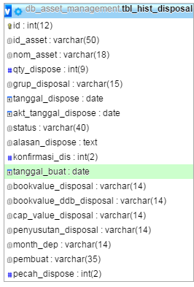

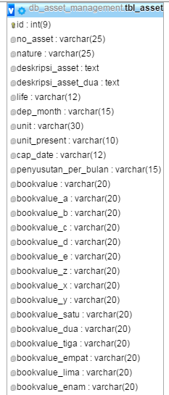
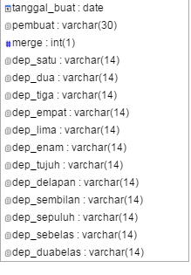
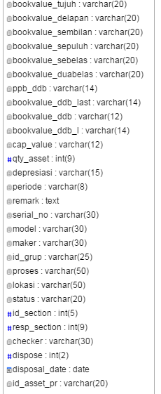

- User Interface
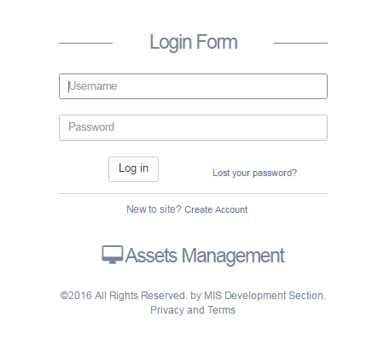

Figure 1Login Form
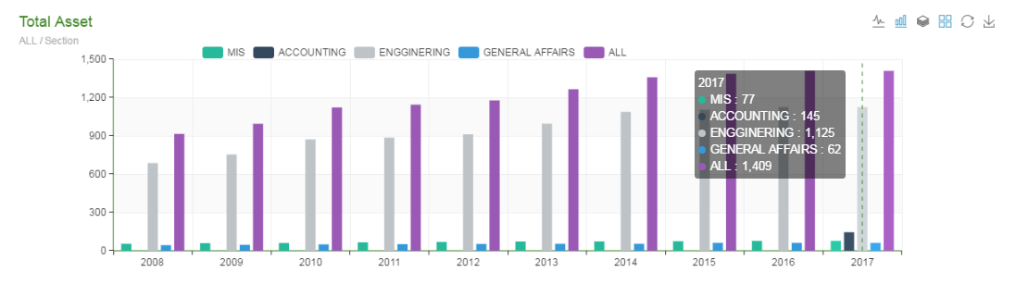

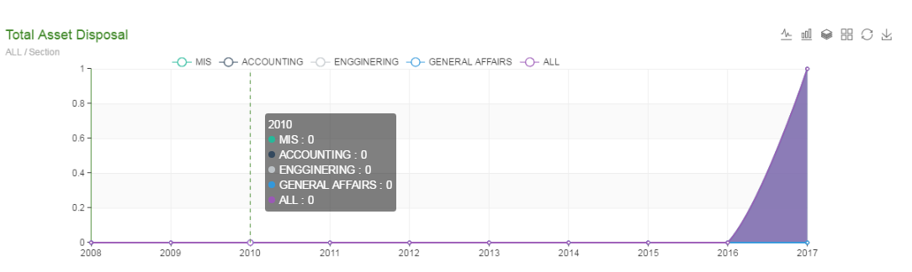

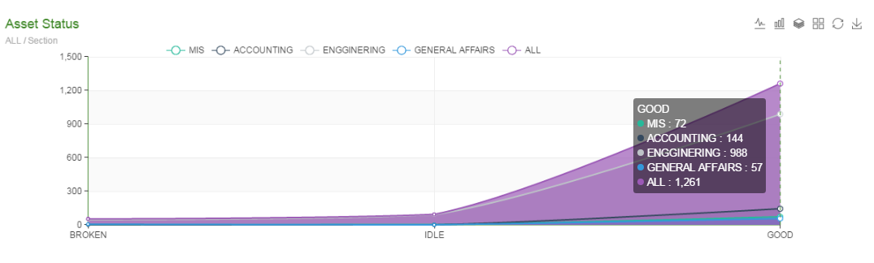

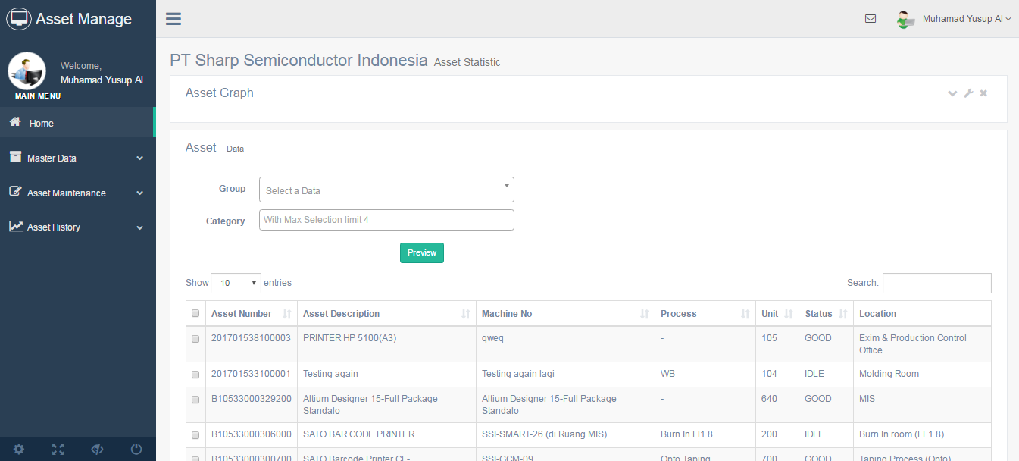
Figure 2 Dashboard Datatable

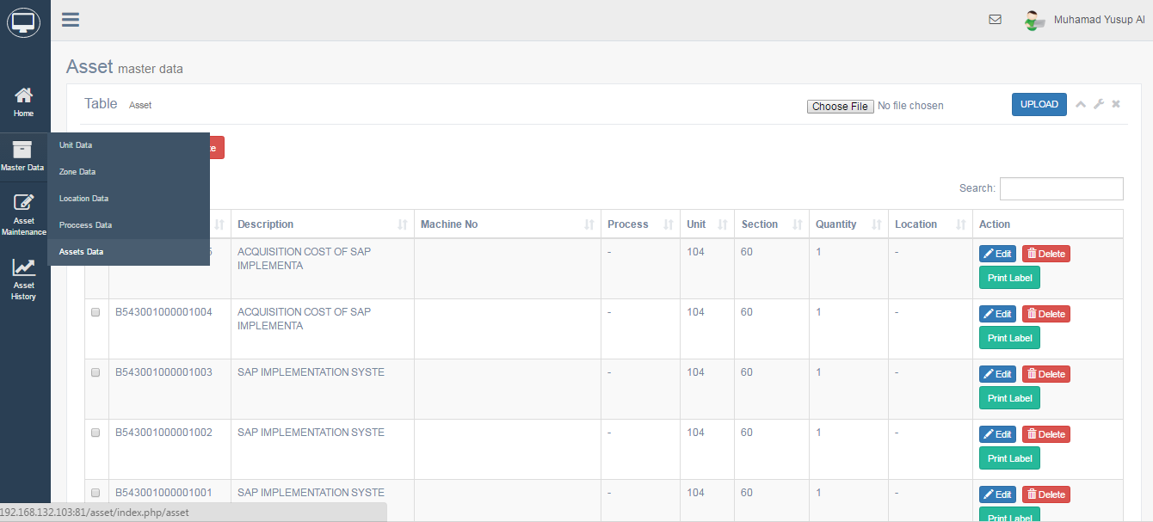
Figure 3 Datatable Asset

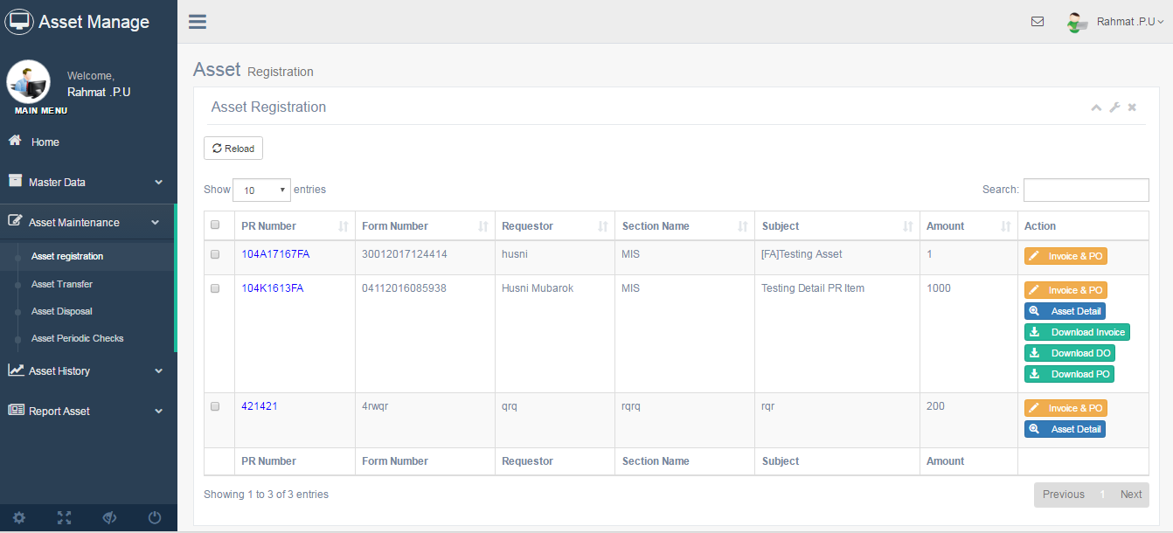
Figure 4 Asset Registration List

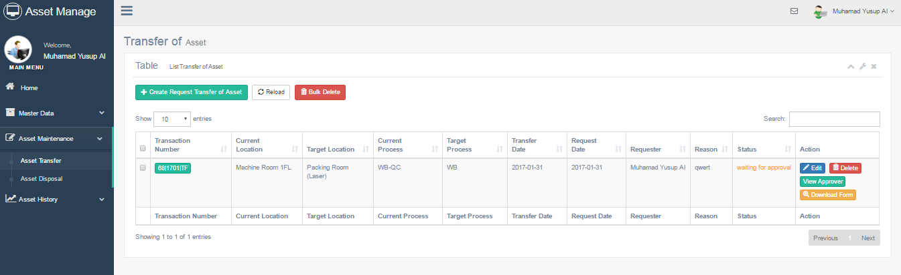
Figure 5 Asset transfer list

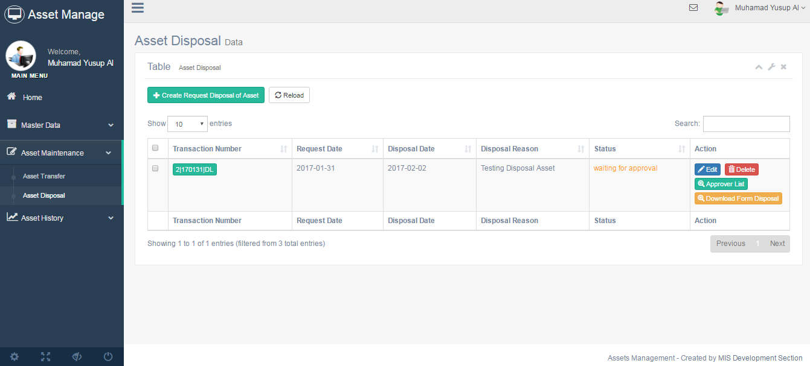
Figure 6 Asset disposal list

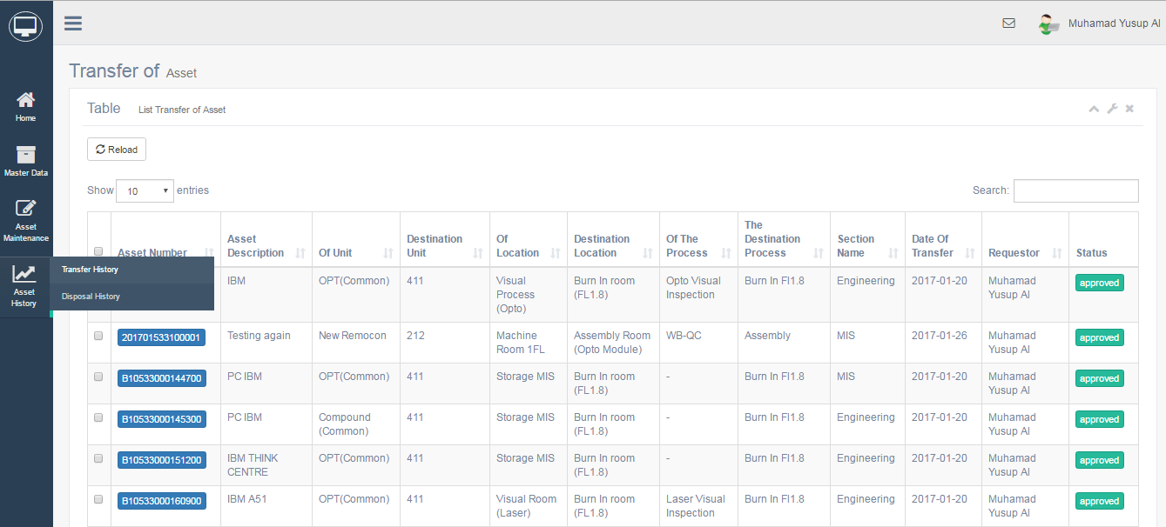
Figure 7 History Transfer List

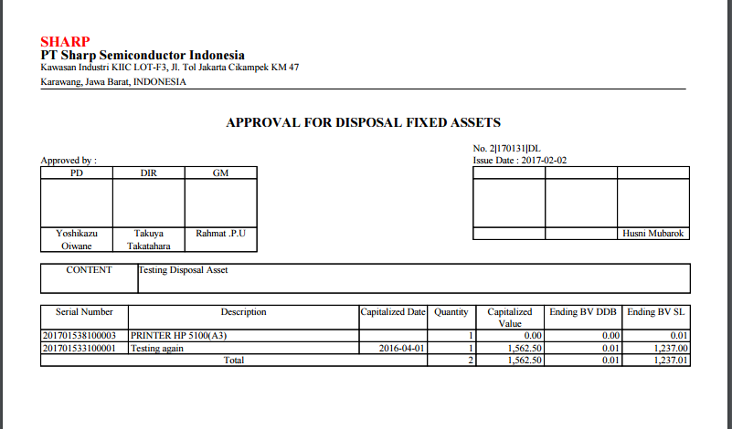
Figure 8 Disposal Form

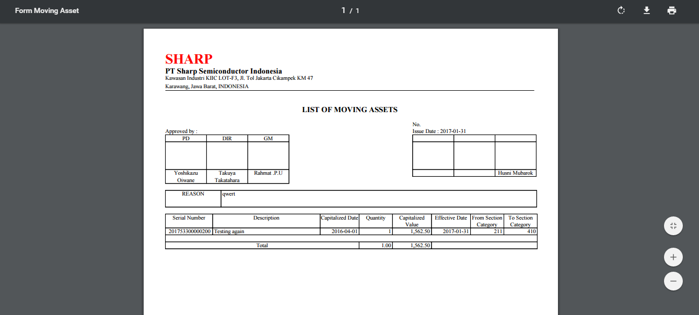
Figure 9 Transfer/Moving Form

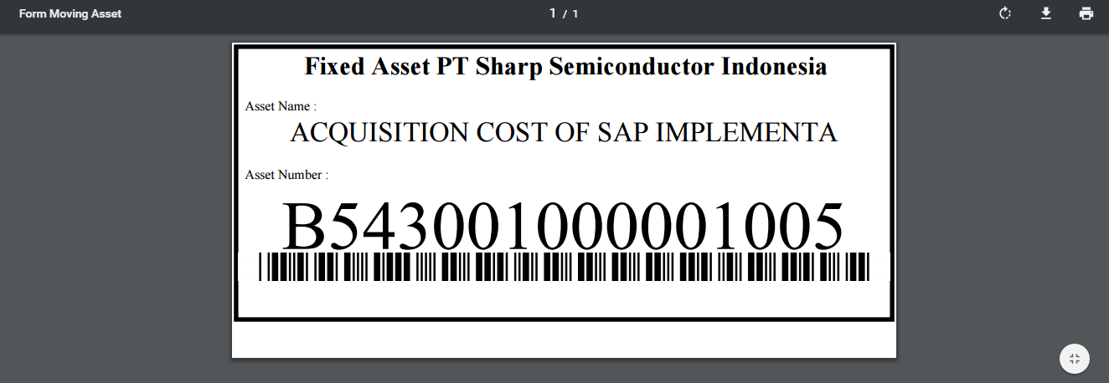
Figure 10 Asset Label
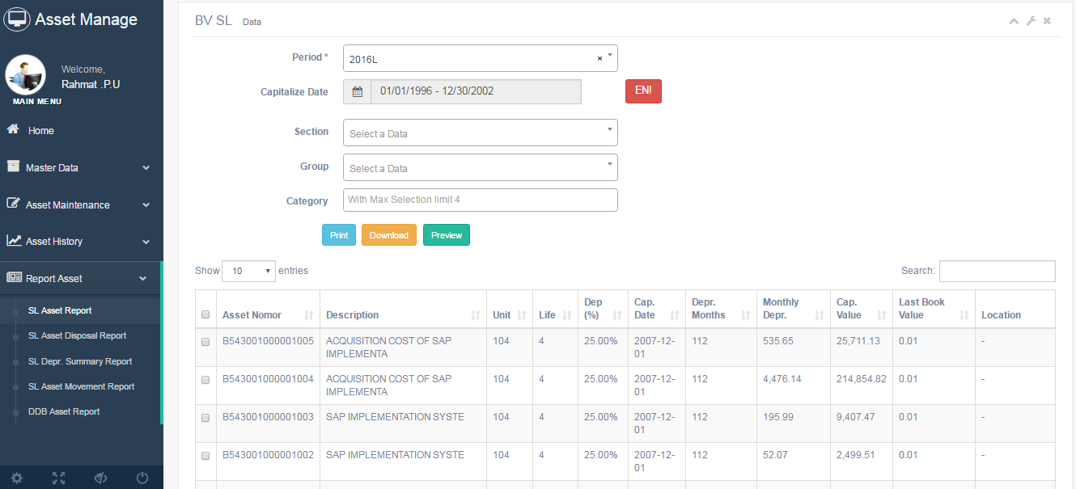
Figure 11 Reports Asset SL

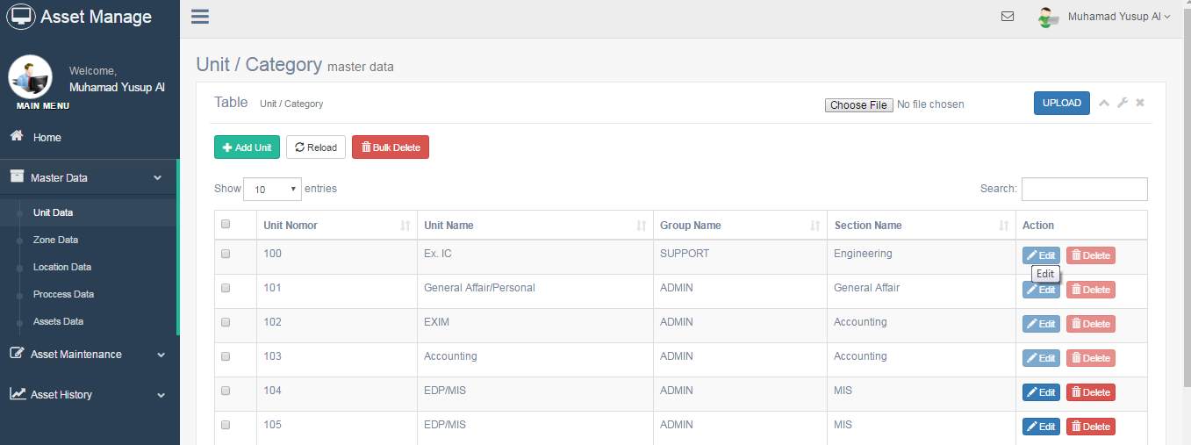
Figure 12 Datatable Unit (Master Table)

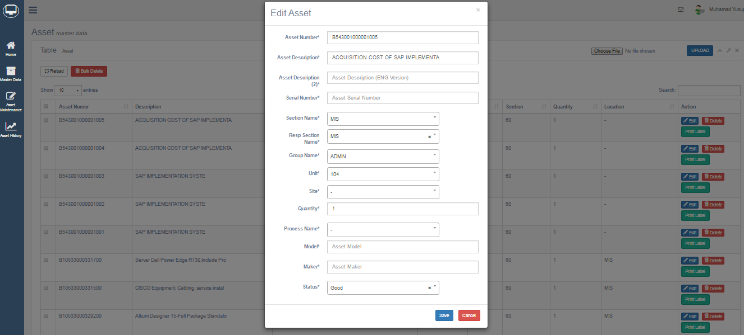
Figure 13 Popup Pages for Add and Edit (Asset)

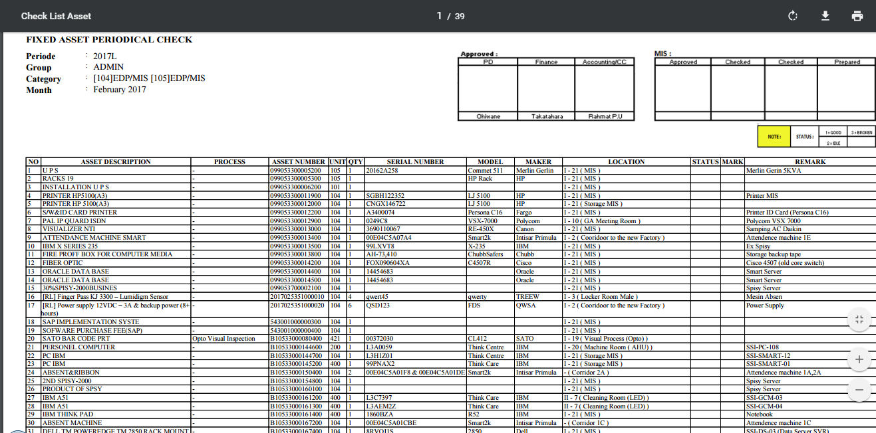
Figure 14 Print Out Check Sheet Assets

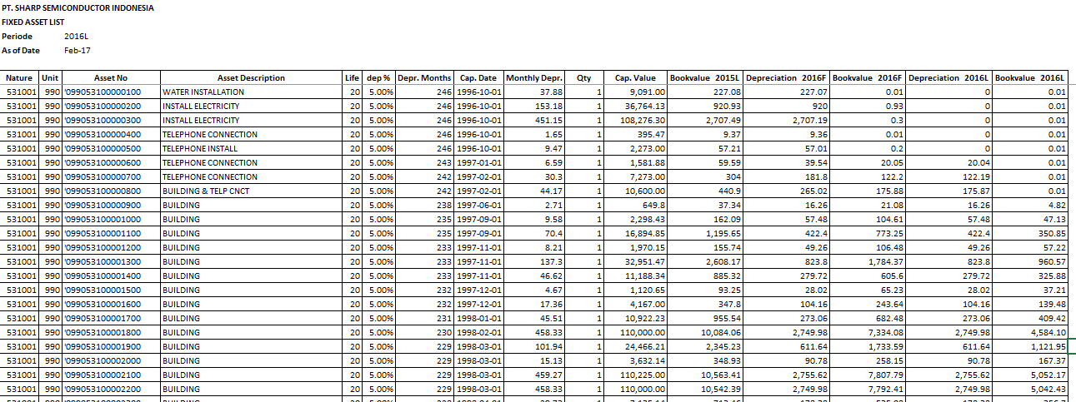
Figure 15 SL Asset Report

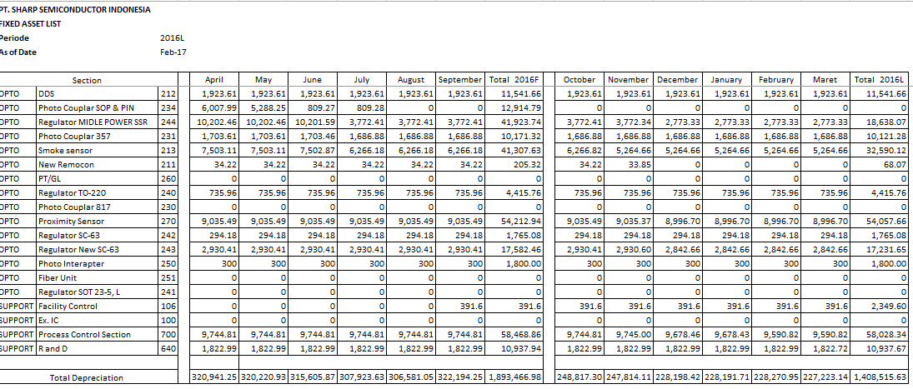
Figure 16 Summary Depreciation Report

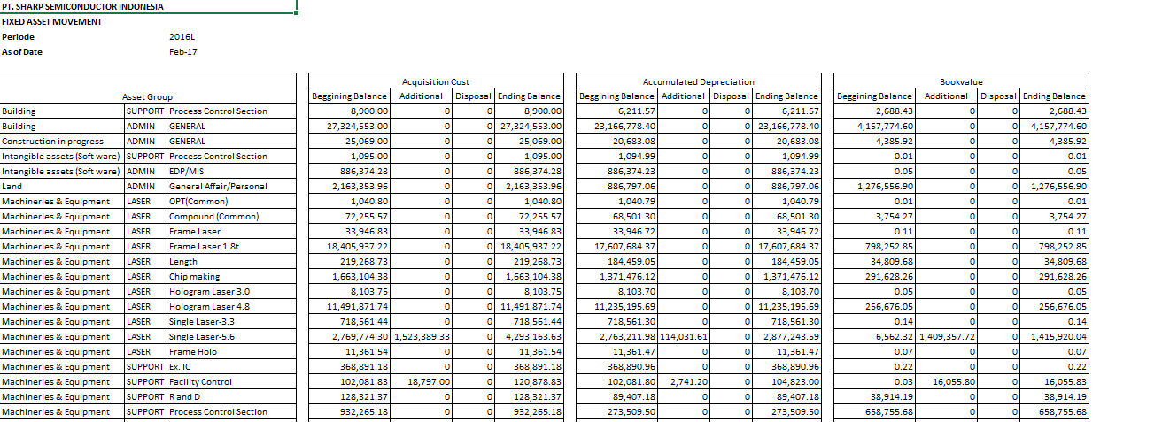
Figure 17 Movement Asset Report

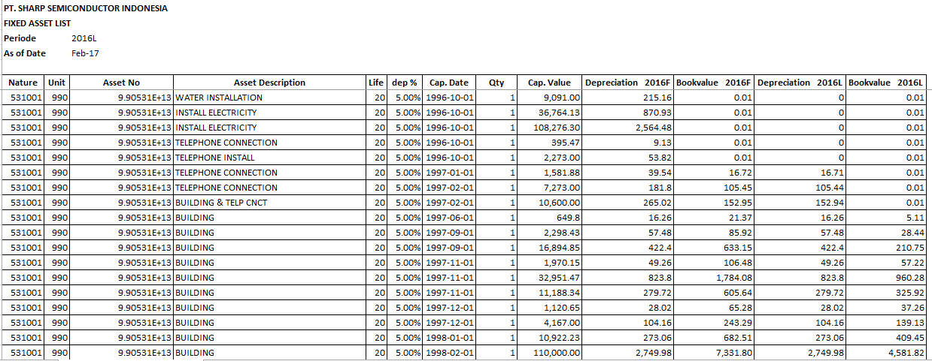
Figure 18 DDB Asset Report

- Testing
This stage is testing the system as a black box, as for some of the steps that might be tested later on this is Asset Management System.

No | Task / Menu | Functions | Descriptions | Validation | Error | Status
1 | Home / Dashboard | Input | Input field with text and select box. | Required | Notification popup appears on the field must be filled | True
1 | Home / Dashboard | Search | Search with trigger Preview Button, and search DataTable with auto complete. | Required | notification appears in the table “No matching records found ” | True

No | Task / Menu | Functions | Descriptions | Validation | Error | Status
1 | Master Data and Transaction | Input | Input field with text and select box. | Required | Notification popup appears on the field must be filled | Success
1 | Master Data and Transaction | Edit / Update | Input field with text and select box with the value that has been specified | Required | Notification popup appears on the field must be filled
1 | Master Data and Transaction | Delete | Delete data with trigger Delete button. | approval | Windows Popup alert with button “Yes” or “No” | Success
1 | Master Data and Transaction | Search | Search with trigger Preview Button, and search DataTable with auto complete. | Required | Notification appears in the table “No matching records found ” | Success
1 | Master Data and Transaction | Print out | Print out data in a format pdf, excel and html. | - | website error and can’t bring up the data | Success

- Maintenance
This stage is the last stage in the development system, where users have started using this system as a whole and MIS staff or developers oversee every transaction that occurs in the system.

- Final Project Schedule

no | Tahap-tahap pengembangan |  | October |  |  |  | November |  |  |  | December |  |  |  | January |  |  |  | February
 | Analysis | Planed | S | S | O | O
 |  | Actual | I | I | I | D
 | Design | Planed |  | S
 |  | Actual |  | D
 | Coding | Planed |  |  | S | S | S | S | O | O | O | O | O | O | O | O | O | O | O | O | O
 |  | Actual |  |  | I | I | I | I | I | I | I | I | I | I | I | I | I | I | I | I | I | D
 | Testing | Planed |  |  |  |  |  |  | S | S | O | O | O | O | O | O | O | O | O | O | O
 |  | Actual |  |  |  |  |  |  |  |  |  |  |  |  |  |  |  |  |  | I | I | D

- Agreement
In connection with the implementation Asset Management System, started at 27 February. MIS will inform about service to Asset Management System.
- Normal Non-Shift Work Time service will be started at 07.30 until 16.30. Outside normal work time, will be conditioned.
- Customization service will be given in 1 month time, after the implementation. Only minor changes , such as interface change, or simple function, and doesn’t need to re-design the system.
- Review for this application will be given in 1 year time. If the application need additional function, or need to re-design the application, MIS section will give schedule in MIS Work plan.
This report is made actually and to be used accordingly.

Karawang, March 2017

Approve,

MIS Section

( Mr. Husni Mubarok ) ( Mr. Evy Setiawan )
Staff Manager

Accounting Section

( Mr. Rahmat P.U )
General Manager

Knowing,

( Mr. Takuya Takatahara )
Director

